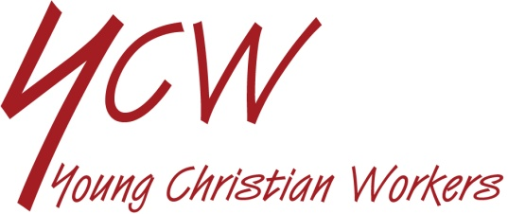

REVIEW OF LIFE ON COMMUNITY WORK

SEE
- What kinds of voluntary work do people do in the community?
- Have you ever volunteered to be involved in some community work or activity? Did you sign up to be an NHS Responder?
- If so describe it and say how you found it and what you gained from it?
- Is there opportunity in your parish to be involved as a volunteer?
- What holds people back from volunteering?

JUDGE
- What talents and qualities do you need to be a volunteer?
- What are the benefits of being involved in some community work or project?

Hear what Pope Francis says:

“Please, do not leave it to others to be protagonists of change. You are the ones who hold the future! Through you, the future enters into the world. I ask you also to be protagonists of this transformation. You are the ones who hold the key to the future! Continue to fight apathy and to offer a Christian response to the social and political troubles emerging in different parts of the world.

I ask you to build the future, to work for a better world. Dear young people, please, do not be bystanders in life. Get involved! Jesus was not a bystander. He got involved. Don’t stand aloof, but immerse yourselves in the reality of life, as Jesus did. Above all, in one way or another, fight for the common good, serve the poor, be protagonists of the revolution of charity and service, capable of resisting …. consumerism and superficial individualism.” (Christus Vivit n.174)

- What does being a “protagonist” mean?
- When are we tempted just to be a bystander?

ACT
- How can we avoid being bystanders?
- Is there something you can volunteer to do or help with?
- Is there a project you are involved in that needs more enthusiasm and commitment?

