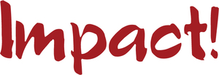
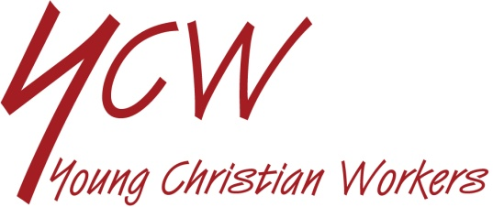

REVIEW OF LIFE ON EDUCATION
SEE
- Have you been working at home over the past two months?
- What have you been studying? How has it been for you? Interesting or difficult or boring?
- Have you missed being at school? If so, what did you miss most?
- What effect has this had on you and your friends? How did your family react to the situation?
- What are you doing differently because of lock-down?
- Have you followed Government regulations and advice with regard to the coronavirus pandemic whilst at home? How easy was it?

JUDGE
- Thinking of your school and education what good things have happened as a result of the pandemic?
- What are the bad results?

Read these words of Pope Francis:

“Christ is alive! He is our hope, and in a wonderful way he brings youth to our world, and everything he touches becomes young, new, full of life. The very first words, then, that I would like to say to every young Christian are these: Christ is alive and he wants you to be alive!

He is in you, he is with you and he never abandons you. However far you may wander, he is always there, the Risen One. He calls you and he waits for you to return to him and start over again. When you feel you are growing old out of sorrow, resentment or fear, doubt or failure, he will always be there to restore your strength and your hope.” (“Christus Vivit” n.1-2)

- Do these words encourage you? How do they make you feel?
- What does being full of life mean for you?
- What helps you feel alive in lock-down?

ACT
- What can we do personally to make things easier for our families at this time?
- Is there something we can appreciate more?
- How could we support each other?

